Orange Dot 6.0 - Locality Profiles

Table of Contents

Families Struggling in Our Region 1

Albemarle County 2

Buckingham County 5

City of Charlottesville 9

Fluvanna County 13

Greene County 17

Louisa County 21

Nelson County 25

## Families Struggling in Our Region

There are 67,760 families living in the Charlottesville region, defined in this report as the City of Charlottesville and the surrounding counties of Albemarle, Buckingham, Fluvanna, Greene, Louisa, and Nelson.[1] Of these, 14,990 families (22%) do not earn enough to provide for their family’s basic needs.

Table : Summary of Struggling Families in the Region

|  | Number of Struggling Families | Percent of Struggling Families |
| --- | --- | --- |
| Albemarle County | 5,010 | 18% |
| Buckingham County | 1,030 | 26% |
| Charlottesville City | 2,370 | 27% |
| Fluvanna County | 1,580 | 21% |
| Greene County | 1,310 | 23% |
| Louisa County | 2,410 | 23% |
| Nelson County | 1,280 | 33% |
| **Total for Region** | **14,990** | **22%** |
| Note: Values are approximate based on the U.S. Census Bureau, American Community Survey 5-year estimates (2018-2022) | | |

### Albemarle County

There are 27,330 families living in Albemarle County. Of these families, 5,010 (18%) do not earn enough to provide for their family’s basic needs.

Albemarle County at a glance:

The Self-Sufficiency Standard for an average family in Albemarle County is an annual income of $63,321.53. This is the income working families need to meet their basic necessities. These include: housing, child care, food, transportation, health care, miscellaneous expenses (clothing, telephone, household items), and taxes (minus federal and state tax credits).

Approximately 5,010 families, or 18% of families, in Albemarle County earn below the Self-Sufficiency Standard.

The percent of Black families earning below the Self-Sufficiency Standard is 46%. The percent of Hispanic families earning below the Self-Sufficiency Standard is 30%. These are 31% and 15% higher than the percent of white families earning below the Self-Sufficiency Standard (15%).

The median family income for Albemarle County is $126,769. The tract with the lowest median family income is Oak Hill, Southwood at $60,700. The tract with the highest median family income is Ivy at $216,300.

The tract with the highest percent of families with income below the Self-Sufficiency Standard is Hydraulic and Oak Hill, Southwood with 49% of families. The tract with the lowest percent of families earning below the Self-Sufficiency Standard is Hollymead with 4% of families. That is a difference of 45%.

Table : Average Expenses and Self-Sufficiency Wages for Families in Albemarle County

|  | Monthly | Annual |
| --- | --- | --- |
| Housing Costs | $1,261.29 | $15,135.48 |
| Child Care Costs | $1,041.73 | $12,500.76 |
| Food Costs | $719.86 | $8,638.32 |
| Transportation Costs | $413.34 | $4,960.08 |
| Health Care Costs | $723.81 | $8,685.72 |
| Miscellaneous Costs | $416.00 | $4,992.00 |
| Taxes | $1,038.95 | $12,467.40 |
| Earned Income Tax Credit | -$1.52 | -$18.24 |
| Child Care Tax Credit | -$70.00 | -$840.00 |
| Child Tax Credit | -$266.67 | -$3,200.04 |
| **Self Sufficiency Wage** | **$5,276.79** | **$63,321.53** |
| Data Source: The Self-Sufficiency Standard for Virginia, 2021; The Center for Women’s Welfare, University of Washington | | |

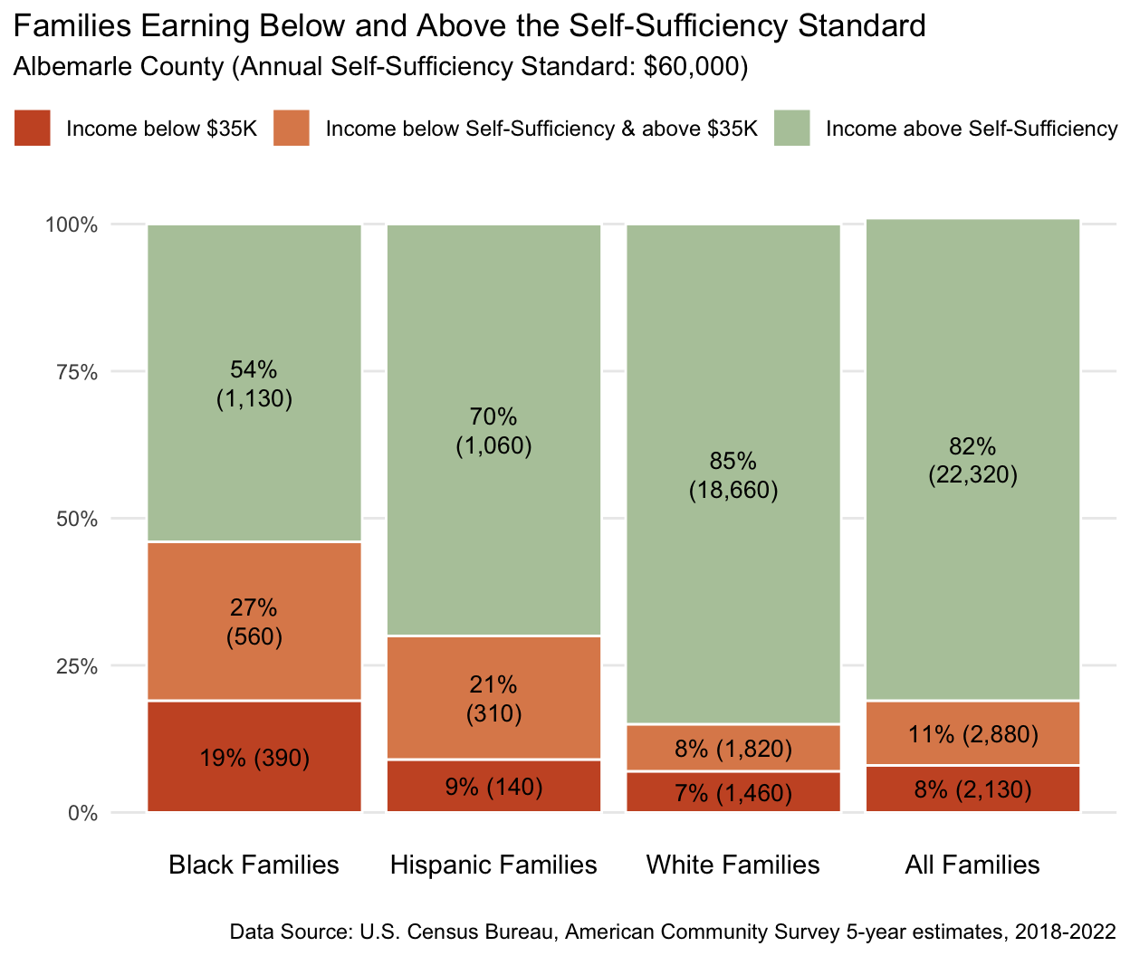

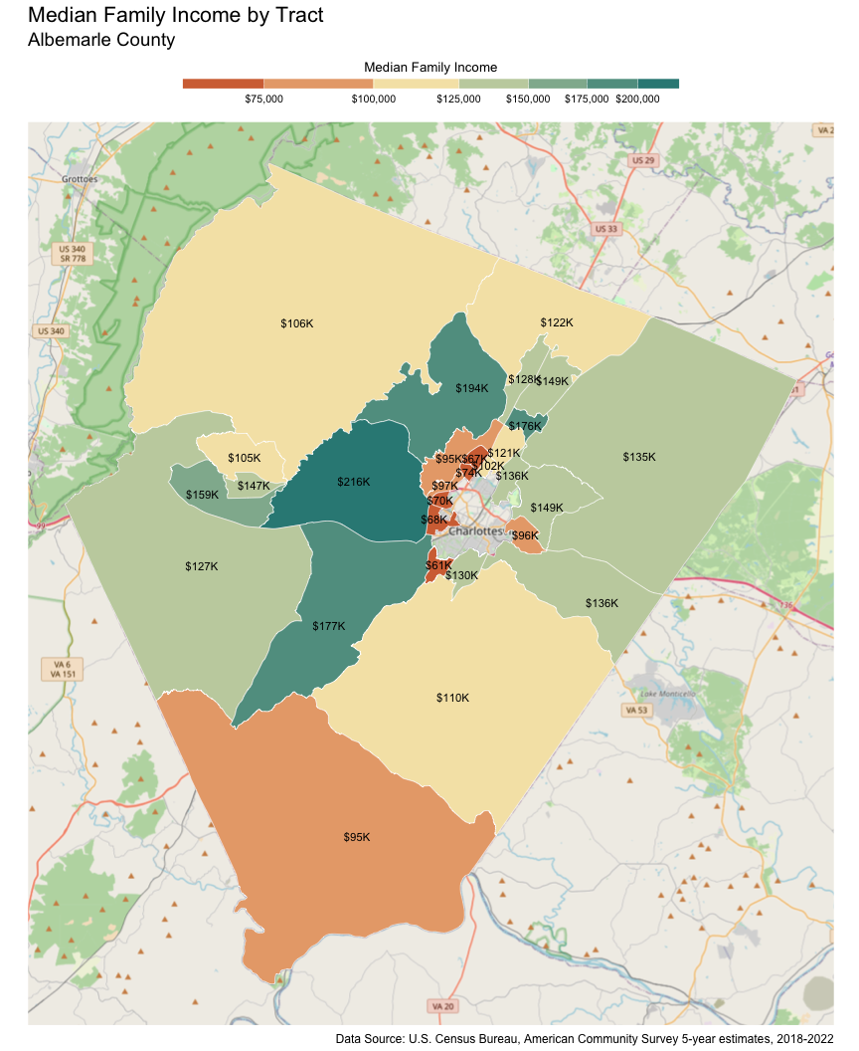

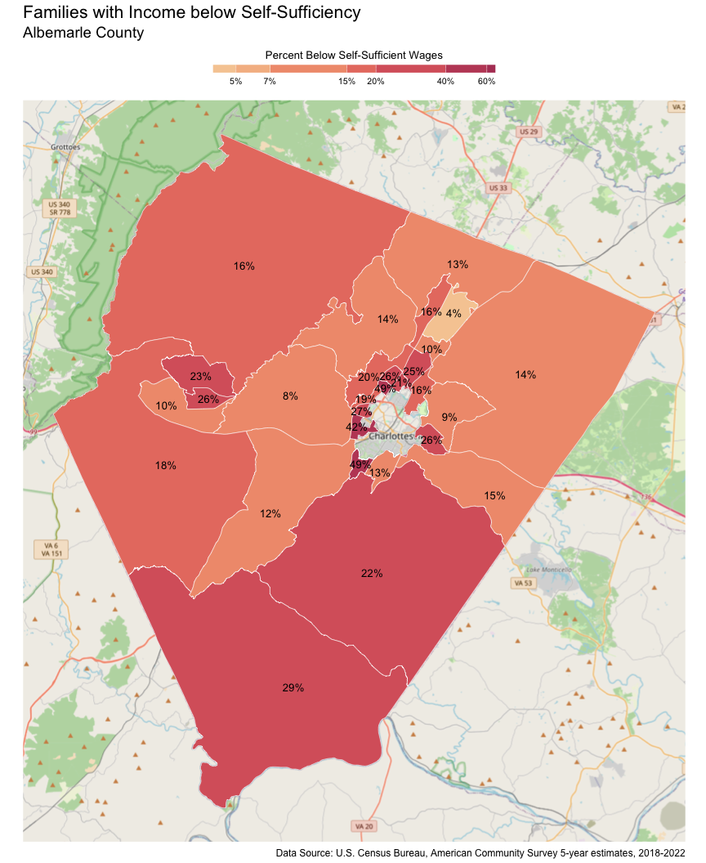

### Buckingham County

There are 3,980 families living in Buckingham County. Of these families, 1,030 (26%) do not earn enough to provide for their family’s basic needs.

Buckingham County at a glance:

The Self-Sufficiency Standard for an average family in Buckingham County is an annual income of $44,475.07. This is the income working families need to meet their basic necessities. These include: housing, child care, food, transportation, health care, miscellaneous expenses (clothing, telephone, household items), and taxes (minus federal and state tax credits).

Approximately 1,030 families, or 26% of families, in Buckingham County earn below the Self-Sufficiency Standard.

The percent of Black families earning below the Self-Sufficiency Standard is 39%. This is 20% higher than the percent of white families earning below the Self-Sufficiency Standard (19%).

The median family income for Buckingham County is $76,351. The tract with the lowest median family income is James River at $66,500. The tract with the highest median family income is Mount Rush at $98,600.

The tract with the highest percent of families with income below the Self-Sufficiency Standard is James River with 34% of families. The tract with the lowest percent of families earning below the Self-Sufficiency Standard is Mount Rush with 16% of families. That is a difference of 18%.

Table : Average Expenses and Self-Sufficiency Wages for Families in Buckingham County

|  | Monthly | Annual |
| --- | --- | --- |
| Housing Costs | $736.93 | $8,843.16 |
| Child Care Costs | $590.85 | $7,090.20 |
| Food Costs | $696.64 | $8,359.68 |
| Transportation Costs | $416.34 | $4,996.08 |
| Health Care Costs | $725.25 | $8,703.00 |
| Miscellaneous Costs | $316.60 | $3,799.20 |
| Taxes | $625.79 | $7,509.48 |
| Earned Income Tax Credit | -$69.28 | -$831.36 |
| Child Care Tax Credit | -$69.79 | -$837.48 |
| Child Tax Credit | -$263.07 | -$3,156.84 |
| **Self Sufficiency Wage** | **$3,706.26** | **$44,475.07** |
| Data Source: The Self-Sufficiency Standard for Virginia, 2021; The Center for Women’s Welfare, University of Washington | | |

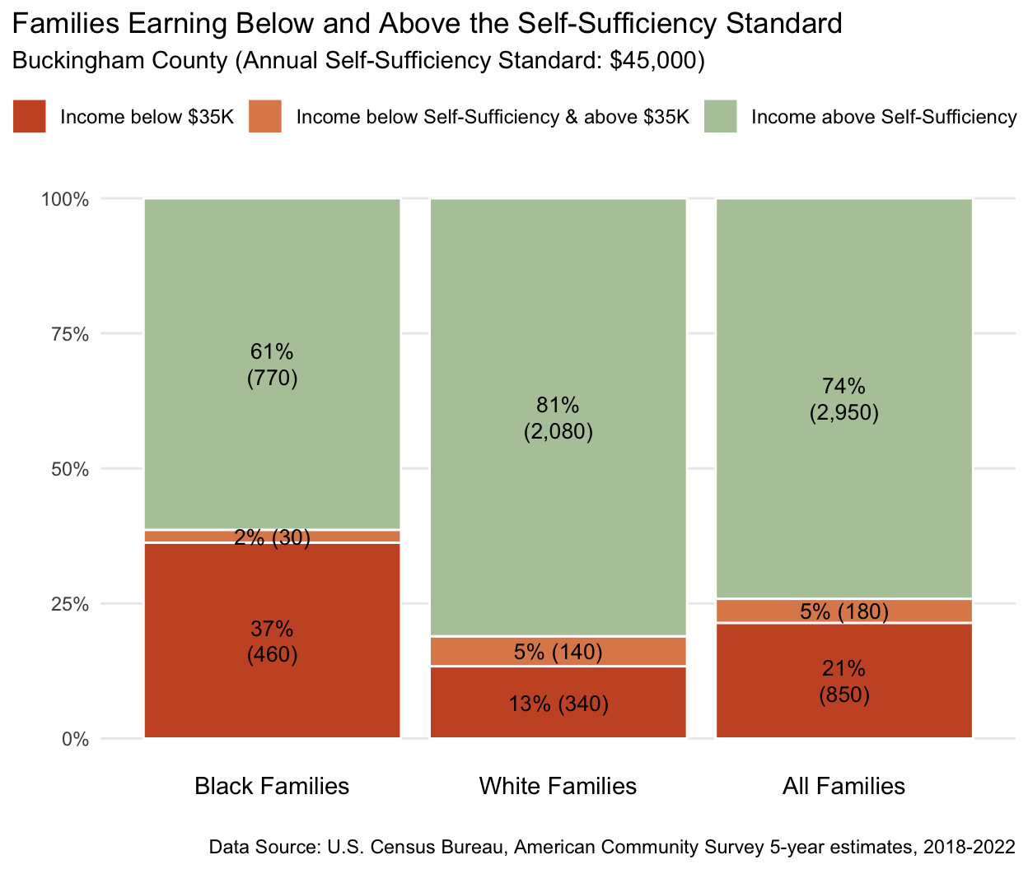

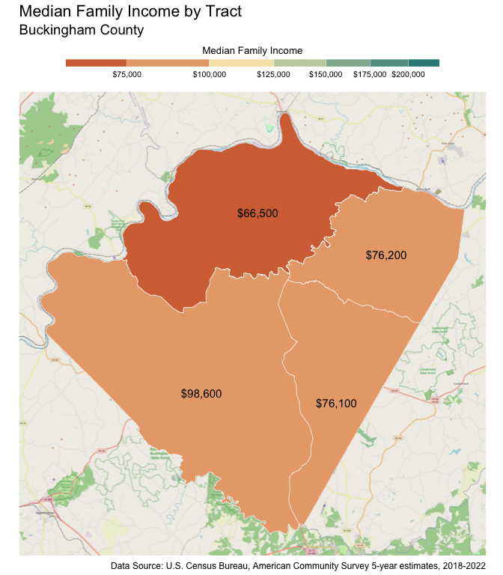

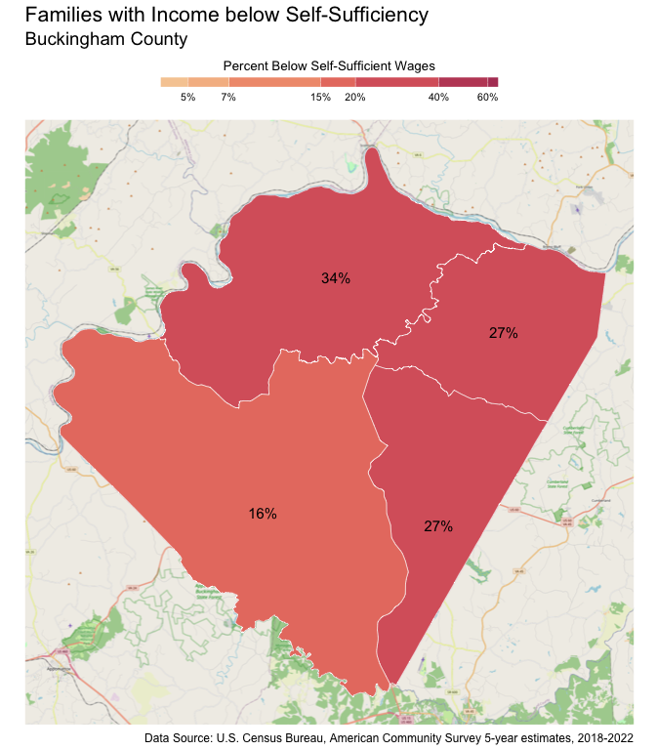

### City of Charlottesville

There are 8,800 families living in Charlottesville City. Of these families, 2,370 (27%) do not earn enough to provide for their family’s basic needs.

Charlottesville City at a glance:

The Self-Sufficiency Standard for an average family in Charlottesville City is an annual income of $60,876.27. This is the income working families need to meet their basic necessities. These include: housing, child care, food, transportation, health care, miscellaneous expenses (clothing, telephone, household items), and taxes (minus federal and state tax credits).

Approximately 2,370 families, or 27% of families, in Charlottesville City earn below the Self-Sufficiency Standard.

The percent of Black families earning below the Self-Sufficiency Standard is 62%. The percent of Hispanic families earning below the Self-Sufficiency Standard is 60%. These are 47% and 45% higher than the percent of white families earning below the Self-Sufficiency Standard (15%).

The median family income for Charlottesville City is $105,994. The tract with the lowest median family income is Fifeville-Cherry Avenue at $61,000. The tract with the highest median family income is Barracks-Rugby at $222,400.

The tract with the highest percent of families with income below the Self-Sufficiency Standard is 10th & Page-Venable with 65% of families. The tract with the lowest percent of families earning below the Self-Sufficiency Standard is Locust Grove with 4% of families. That is a difference of 61%.

Table : Average Expenses and Self-Sufficiency Wages for Families in Charlottesville City

|  | Monthly | Annual |
| --- | --- | --- |
| Housing Costs | $1,279.26 | $15,351.12 |
| Child Care Costs | $1,041.73 | $12,500.76 |
| Food Costs | $943.63 | $11,323.56 |
| Transportation Costs | $30.00 | $360.00 |
| Health Care Costs | $723.81 | $8,685.72 |
| Miscellaneous Costs | $401.84 | $4,822.08 |
| Taxes | $992.56 | $11,910.72 |
| Earned Income Tax Credit | -$3.14 | -$37.68 |
| Child Care Tax Credit | -$70.00 | -$840.00 |
| Child Tax Credit | -$266.67 | -$3,200.04 |
| **Self Sufficiency Wage** | **$5,073.02** | **$60,876.27** |
| Data Source: The Self-Sufficiency Standard for Virginia, 2021; The Center for Women’s Welfare, University of Washington | | |

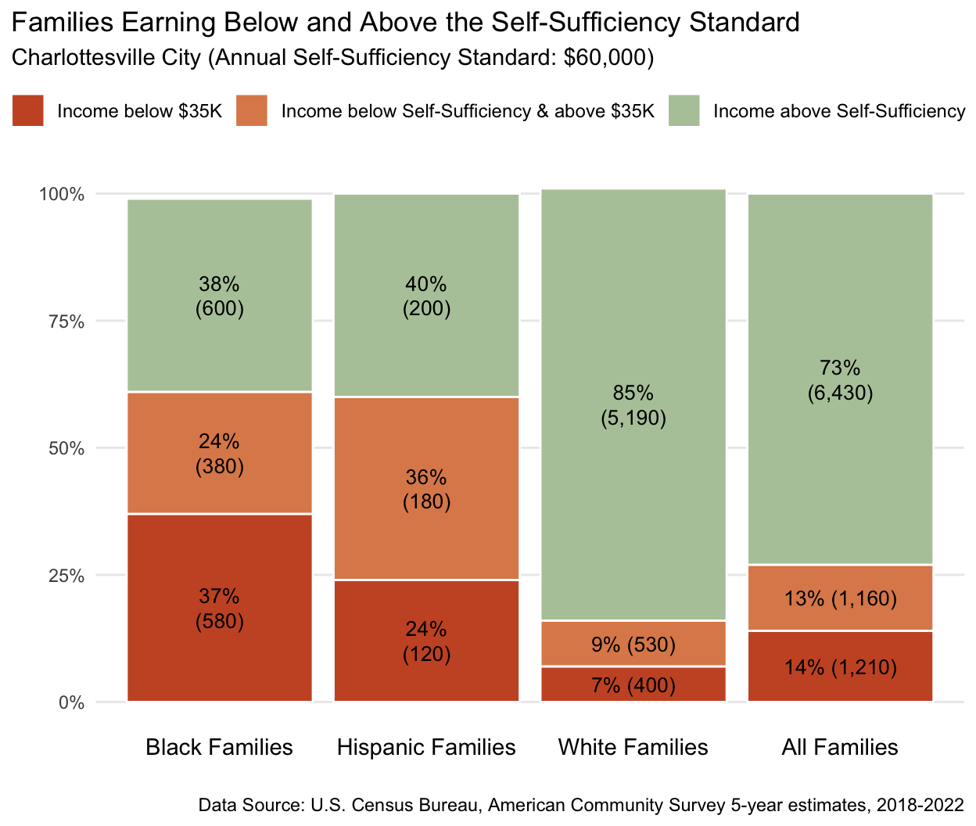

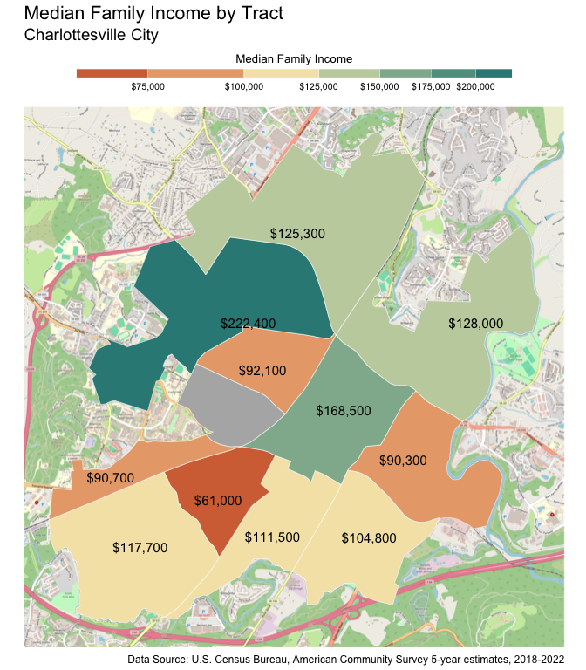

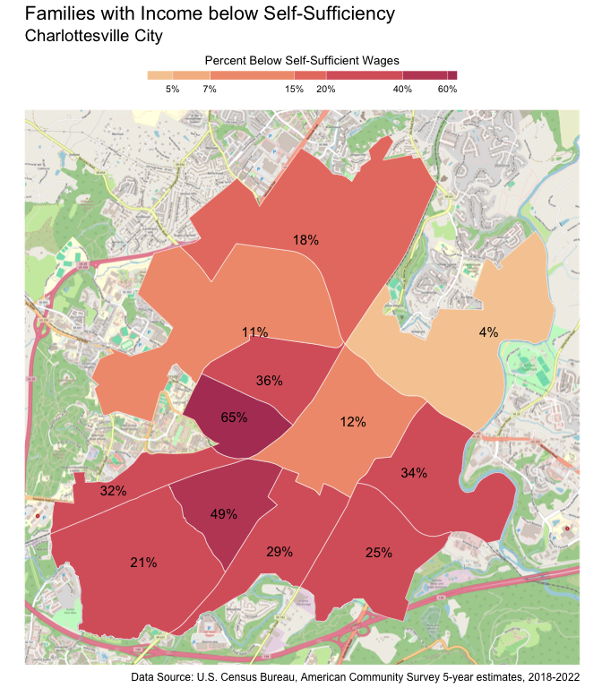

### Fluvanna County

There are 7,430 families living in Fluvanna County. Of these families, 1,580 (21%) do not earn enough to provide for their family’s basic needs.

Fluvanna County at a glance:

The Self-Sufficiency Standard for an average family in Fluvanna County is an annual income of $59,819.1. This is the income working families need to meet their basic necessities. These include: housing, child care, food, transportation, health care, miscellaneous expenses (clothing, telephone, household items), and taxes (minus federal and state tax credits).

Approximately 1,580 families, or 21% of families, in Fluvanna County earn below the Self-Sufficiency Standard.

The percent of Black families earning below the Self-Sufficiency Standard is 31%. This is 12% higher than the percent of white families earning below the Self-Sufficiency Standard (19%).

The median family income for Fluvanna County is $102,060. The tract with the lowest median family income is Columbia/Fork Union at $69,000. The tract with the highest median family income is Lake Monticello at $112,400.

The tract with the highest percent of families with income below the Self-Sufficiency Standard is Columbia/Fork Union with 37% of families. The tract with the lowest percent of families earning below the Self-Sufficiency Standard is Rivanna with 17% of families. That is a difference of 20%.

Table : Average Expenses and Self-Sufficiency Wages for Families in Fluvanna County

|  | Monthly | Annual |
| --- | --- | --- |
| Housing Costs | $1,333.76 | $16,005.12 |
| Child Care Costs | $726.94 | $8,723.28 |
| Food Costs | $759.97 | $9,119.64 |
| Transportation Costs | $416.34 | $4,996.08 |
| Health Care Costs | $723.81 | $8,685.72 |
| Miscellaneous Costs | $396.08 | $4,752.96 |
| Taxes | $963.75 | $11,565.00 |
| Earned Income Tax Credit | $0.00 | $0.00 |
| Child Care Tax Credit | -$69.06 | -$828.72 |
| Child Tax Credit | -$266.67 | -$3,200.04 |
| **Self Sufficiency Wage** | **$4,984.92** | **$59,819.10** |
| Data Source: The Self-Sufficiency Standard for Virginia, 2021; The Center for Women’s Welfare, University of Washington | | |

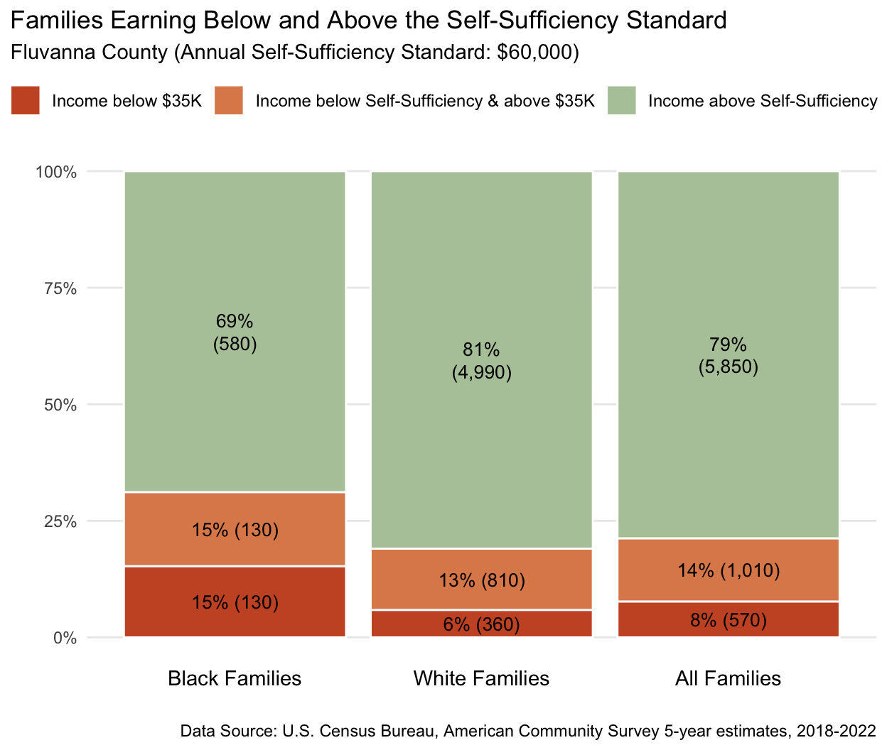

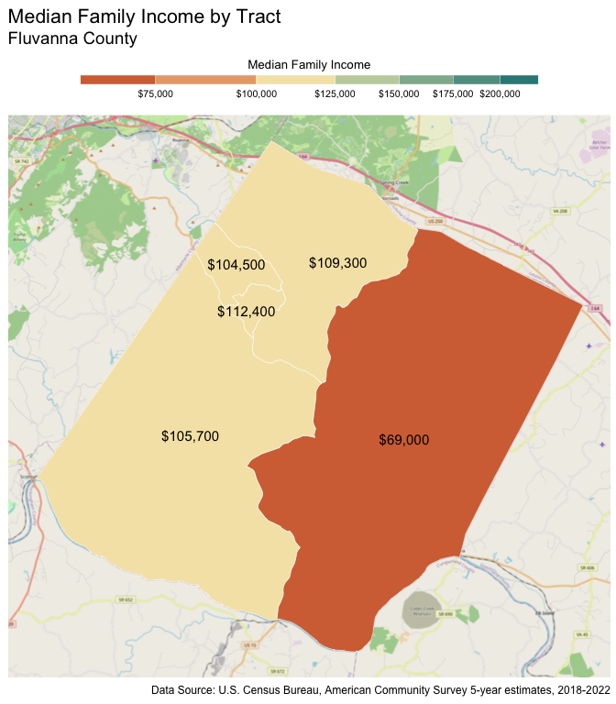

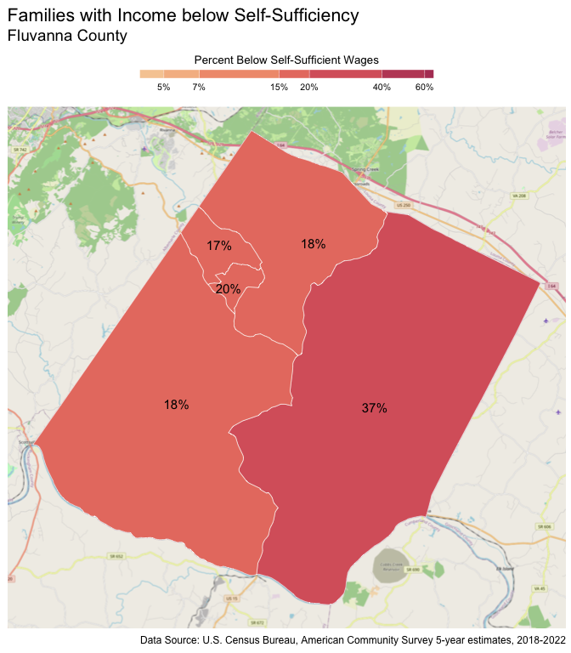

### Greene County

There are 5,750 families living in Greene County. Of these families, 1,310 (23%) do not earn enough to provide for their family’s basic needs.

Greene County at a glance:

The Self-Sufficiency Standard for an average family in Greene County is an annual income of $55,744.55. This is the income working families need to meet their basic necessities. These include: housing, child care, food, transportation, health care, miscellaneous expenses (clothing, telephone, household items), and taxes (minus federal and state tax credits).

Approximately 1,310 families, or 23% of families, in Greene County earn below the Self-Sufficiency Standard.

The percent of Black families earning below the Self-Sufficiency Standard is 64%. This is 45% higher than the percent of white families earning below the Self-Sufficiency Standard (19%).

The median family income for Greene County is $91,135. The tract with the lowest median family income is Stanardsville at $71,900. The tract with the highest median family income is Midway at $117,700.

The tract with the highest percent of families with income below the Self-Sufficiency Standard is Stanardsville with 37% of families. The tract with the lowest percent of families earning below the Self-Sufficiency Standard is Midway with 15% of families. That is a difference of 22%.

Table : Average Expenses and Self-Sufficiency Wages for Families in Greene County

|  | Monthly | Annual |
| --- | --- | --- |
| Housing Costs | $1,150.43 | $13,805.16 |
| Child Care Costs | $724.94 | $8,699.28 |
| Food Costs | $724.08 | $8,688.96 |
| Transportation Costs | $413.34 | $4,960.08 |
| Health Care Costs | $723.81 | $8,685.72 |
| Miscellaneous Costs | $373.66 | $4,483.92 |
| Taxes | $875.65 | $10,507.80 |
| Earned Income Tax Credit | -$4.81 | -$57.72 |
| Child Care Tax Credit | -$69.06 | -$828.72 |
| Child Tax Credit | -$266.67 | -$3,200.04 |
| **Self Sufficiency Wage** | **$4,645.38** | **$55,744.55** |
| Data Source: The Self-Sufficiency Standard for Virginia, 2021; The Center for Women’s Welfare, University of Washington | | |

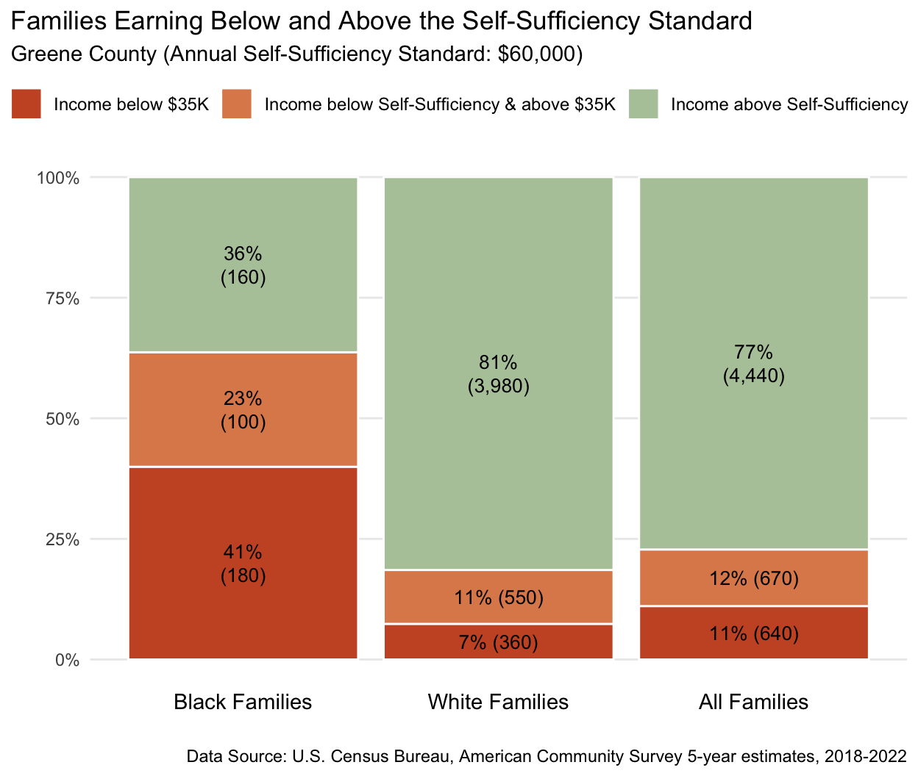

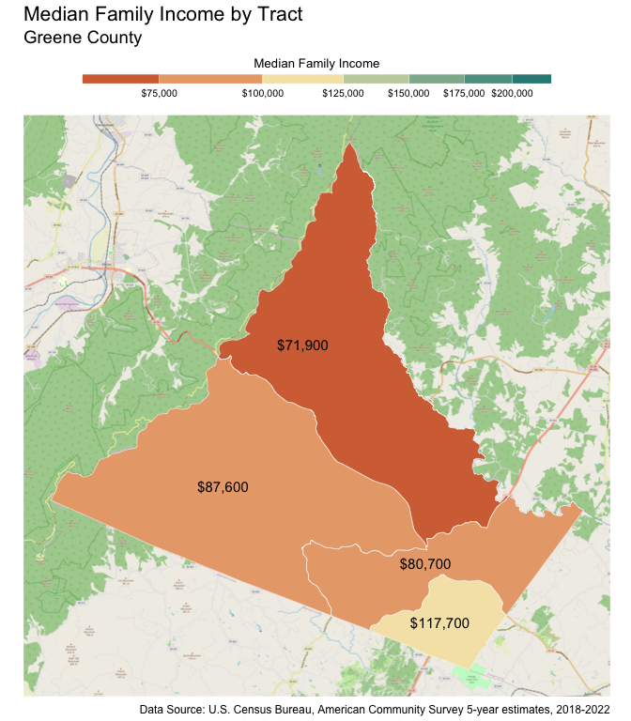

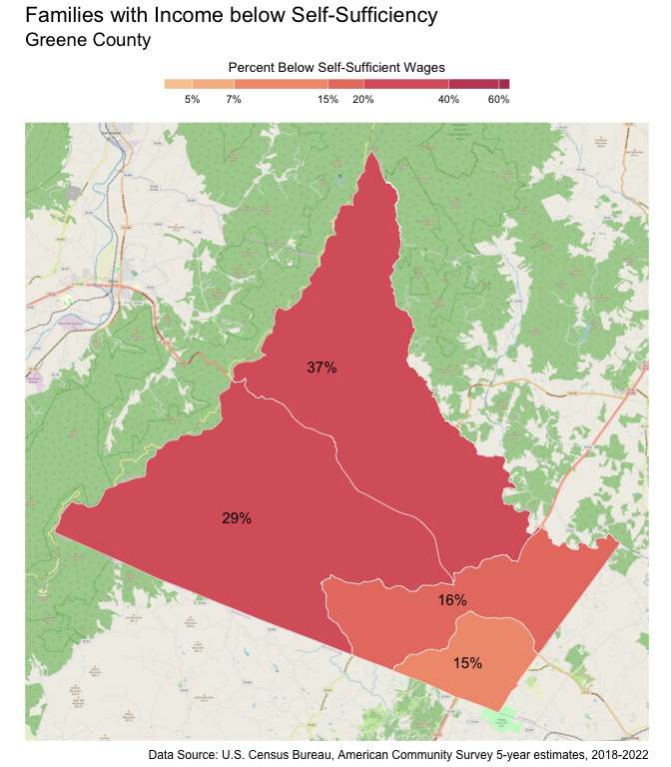

### Louisa County

There are 10,550 families living in Louisa County. Of these families, 2,410 (23%) do not earn enough to provide for their family’s basic needs.

Louisa County at a glance:

The Self-Sufficiency Standard for an average family in Louisa County is an annual income of $49,157.87. This is the income working families need to meet their basic necessities. These include: housing, child care, food, transportation, health care, miscellaneous expenses (clothing, telephone, household items), and taxes (minus federal and state tax credits).

Approximately 2,410 families, or 23% of families, in Louisa County earn below the Self-Sufficiency Standard.

The percent of Black families earning below the Self-Sufficiency Standard is 46%. This is 27% higher than the percent of white families earning below the Self-Sufficiency Standard (19%).

The median family income for Louisa County is $93,231. The tract with the lowest median family income is Ferncliff-Shannon Hill (Yanceyville) at $70,200. The tract with the highest median family income is Bumpus-Mountain Road District-Buckner at $126,700.

The tract with the highest percent of families with income below the Self-Sufficiency Standard is Cuckoo District with 32% of families. The tract with the lowest percent of families earning below the Self-Sufficiency Standard is Zion Crossroads with 12% of families. That is a difference of 20%.

Table : Average Expenses and Self-Sufficiency Wages for Families in Louisa County

|  | Monthly | Annual |
| --- | --- | --- |
| Housing Costs | $903.53 | $10,842.36 |
| Child Care Costs | $724.94 | $8,699.28 |
| Food Costs | $681.86 | $8,182.32 |
| Transportation Costs | $416.34 | $4,996.08 |
| Health Care Costs | $670.22 | $8,042.64 |
| Miscellaneous Costs | $339.69 | $4,076.28 |
| Taxes | $729.66 | $8,755.92 |
| Earned Income Tax Credit | -$33.63 | -$403.56 |
| Child Care Tax Credit | -$69.52 | -$834.24 |
| Child Tax Credit | -$266.61 | -$3,199.32 |
| **Self Sufficiency Wage** | **$4,096.49** | **$49,157.87** |
| Data Source: The Self-Sufficiency Standard for Virginia, 2021; The Center for Women’s Welfare, University of Washington | | |

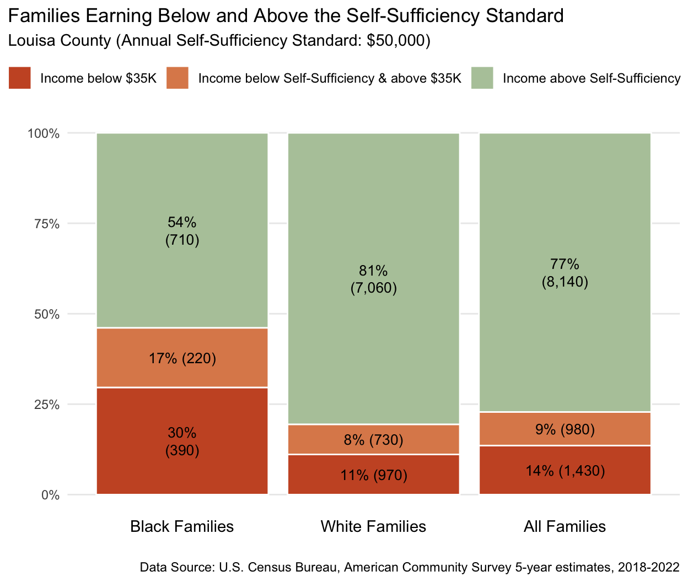

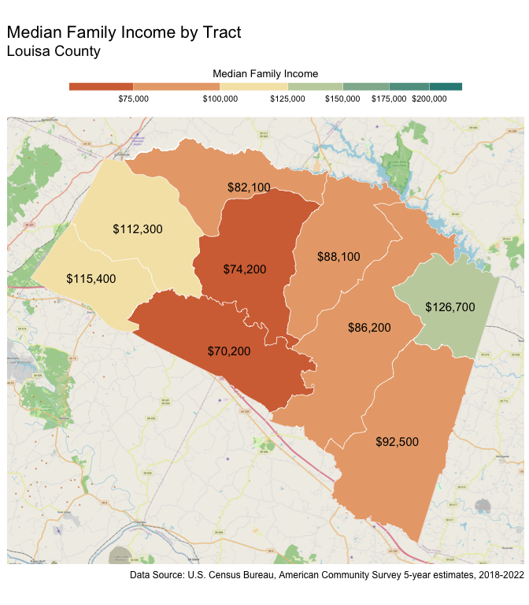

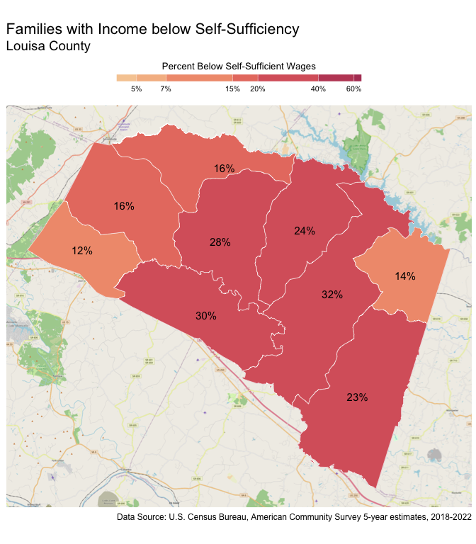

### Nelson County

There are 3,920 families living in Nelson County. Of these families, 1,280 (33%) do not earn enough to provide for their family’s basic needs.

Nelson County at a glance:

The Self-Sufficiency Standard for an average family in Nelson County is an annual income of $54,249.45. This is the income working families need to meet their basic necessities. These include: housing, child care, food, transportation, health care, miscellaneous expenses (clothing, telephone, household items), and taxes (minus federal and state tax credits).

Approximately 1,280 families, or 33% of families, in Nelson County earn below the Self-Sufficiency Standard.

The percent of Black families earning below the Self-Sufficiency Standard is 33%. This is 1% higher than the percent of white families earning below the Self-Sufficiency Standard (32%).

The median family income for Nelson County is $84,974. The tract with the lowest median family income is Wintergreen-Wingina at $63,200. The tract with the highest median family income is Wintergreen-Rockfish Valley at $137,600.

The tract with the highest percent of families with income below the Self-Sufficiency Standard is Wintergreen-Wingina with 42% of families. The tract with the lowest percent of families earning below the Self-Sufficiency Standard is Wintergreen-Rockfish Valley with 19% of families. That is a difference of 23%.

Table : Average Expenses and Self-Sufficiency Wages for Families in Nelson County

|  | Monthly | Annual |
| --- | --- | --- |
| Housing Costs | $1,108.65 | $13,303.80 |
| Child Care Costs | $731.92 | $8,783.04 |
| Food Costs | $683.97 | $8,207.64 |
| Transportation Costs | $410.34 | $4,924.08 |
| Health Care Costs | $723.81 | $8,685.72 |
| Miscellaneous Costs | $365.87 | $4,390.44 |
| Taxes | $841.14 | $10,093.68 |
| Earned Income Tax Credit | -$8.94 | -$107.28 |
| Child Care Tax Credit | -$69.30 | -$831.60 |
| Child Tax Credit | -$266.67 | -$3,200.04 |
| **Self Sufficiency Wage** | **$4,520.79** | **$54,249.45** |
| Data Source: The Self-Sufficiency Standard for Virginia, 2021; The Center for Women’s Welfare, University of Washington | | |

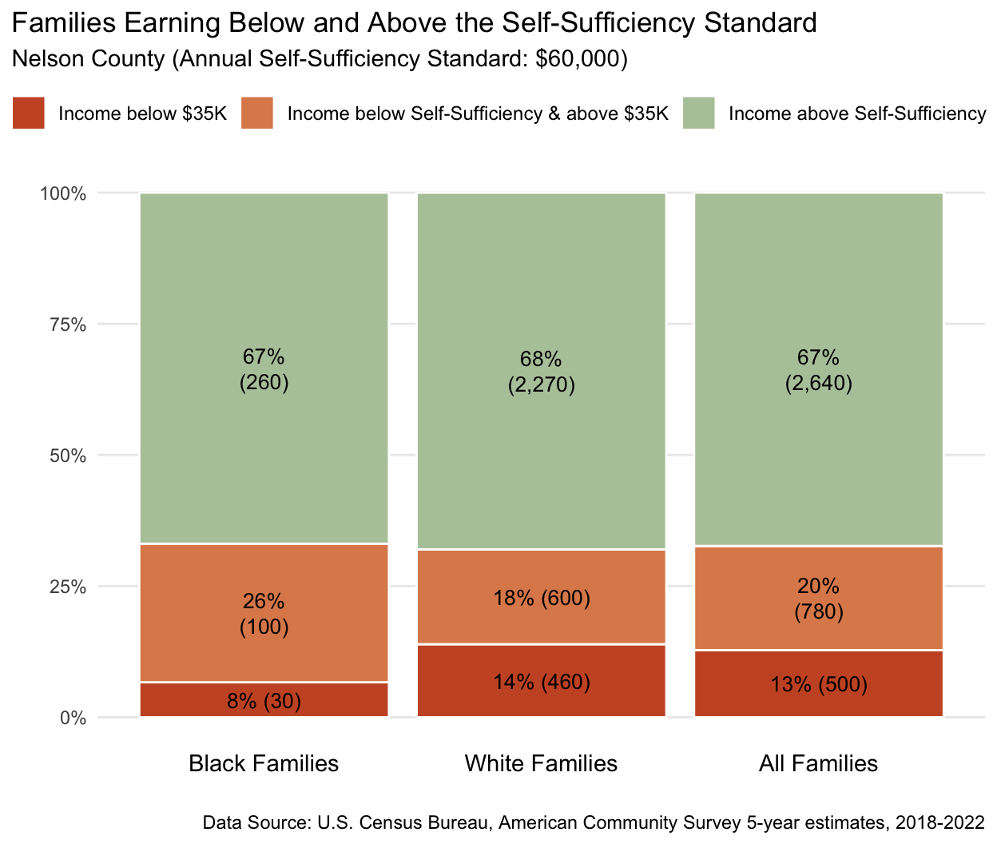

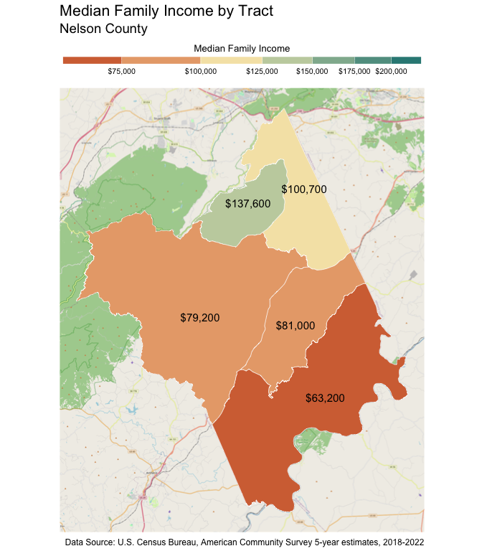

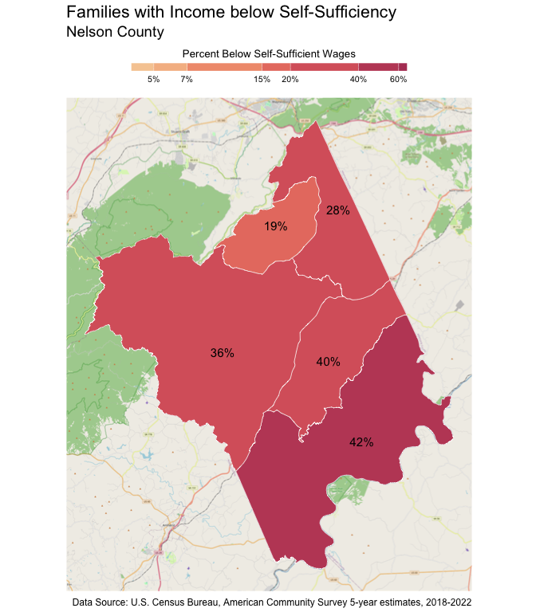

1. Family is defined as two or more people related by birth, marriage, or adoption and living in the same household.